**World Quant University**

**Professor: Harry Wang**

**Algorithms II**

Nikolas Lippmann Pareschi - [nikolaslippmann@gmail.com](mailto:nikolaslippmann@gmail.com)

**Assignment 6: Formulating Problems as Linear Programs**

### Problem 1:  The Knight’s Tour On A Chess Noard

Consider the knight’s tour on a chess board: A knight selects one of the next positions at random.

1.  Why is this process a Markov chain?

2.  What is the state space?

1. A Markov Chain is "a [stochastic model](https://en.wikipedia.org/wiki/Stochastic_model) describing a [sequence](https://en.wikipedia.org/wiki/Sequence) of possible events in which the probability of each event depends only on the state attained in the previous event. [1] As the knight next position (N+1) depends only on the present N position (memoryless) and its next position is randomly, independently defined from the position N this process is a Markov one. It is also a Markov chain because its space is discrete [2].
2. If the knight is able to run all the chessboard the state space would be the set of the squares of the chess board. Actually, this is a classical problem in chess [3]:



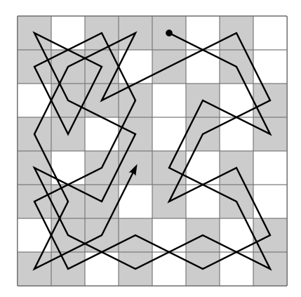

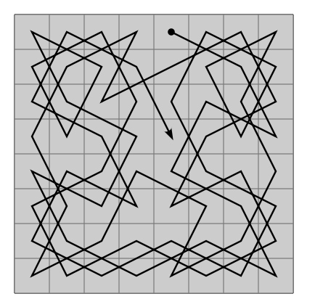[4]

As it is possible the S will be all the 64 squares.

There are 8x8 = 64 squares. The state space is:

S = {(i1, i2): 1<= i1 <= 8, 1 <= i2 <= 8} = {1, 2, 3, 4, 5, 6, 7, 8} x {1, 2, 3, 4, 5, 6, 7, 8}.

We were able to run all the 64 squares of the chess boards in this python program [4]. I made some minor adaptations when running the program (one needs to select 8 as N and 0x0 as the initial position of our problem.

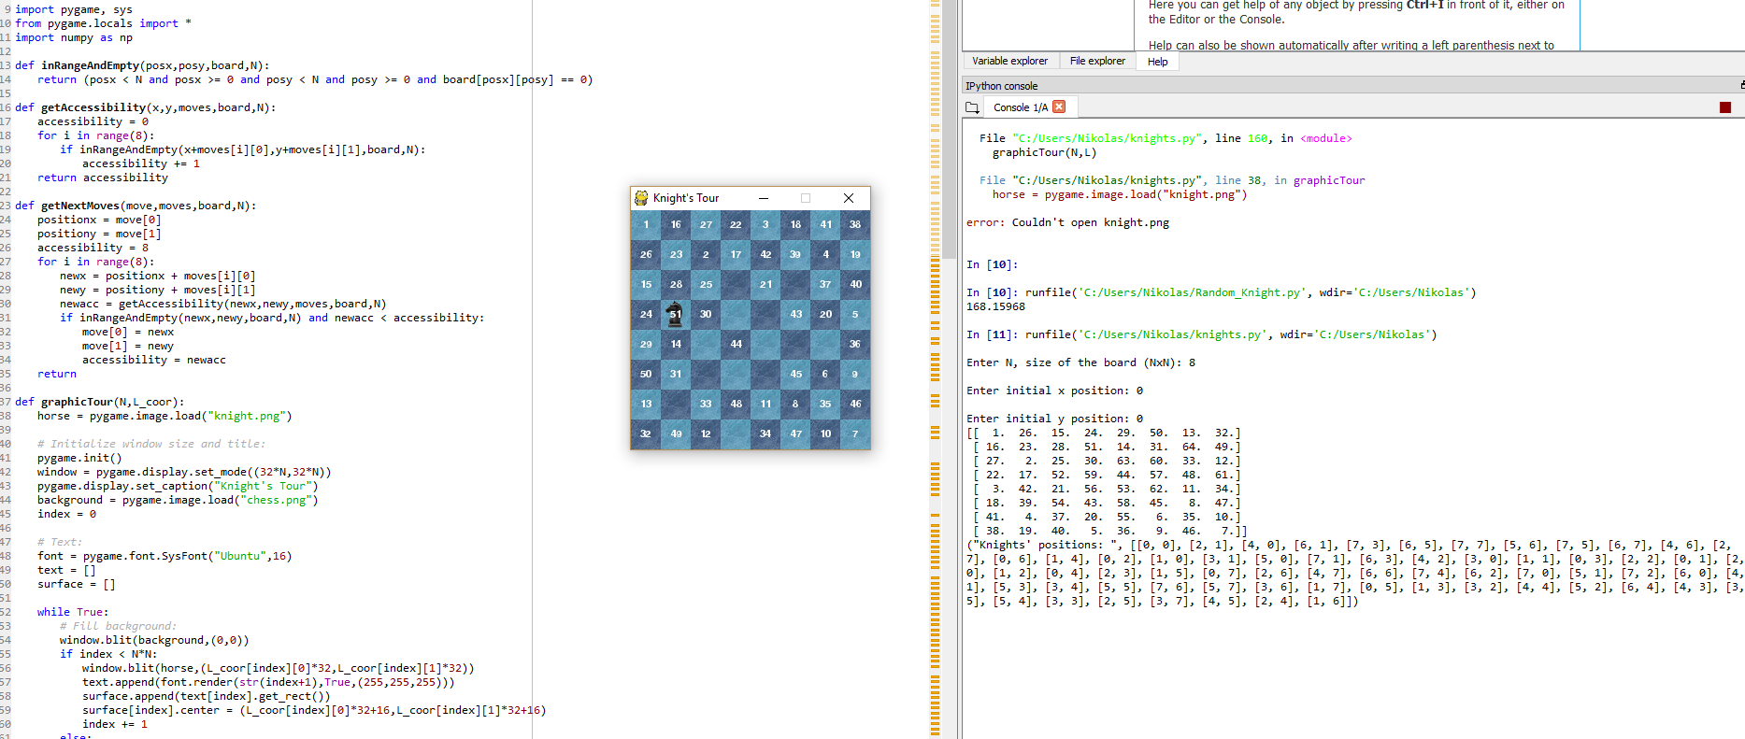

[1] <https://en.wikipedia.org/wiki/Markov_chain>

[2] <https://en.wikipedia.org/wiki/Markov_chain>

[3] <https://www.quora.com/How-do-I-make-the-knight-pass-through-all-squares-in-the-chess-board>

[4] <https://github.com/RodolfoFerro/KnightsTour>